MSE Duration
Music selection | Notes
Scripting for MSE

Music counts / reps / sets | Exercise | Teaching / coaching points  Please also clearly show where you will use silence and motivation techniques | Progressions (H) – regressions (E) – any other modification or adaptions (optional)
You will plan – as a minimum – Ab curls, Press ups and Dorsal raises. You can add further exercises if you wish.
ABDOMINAL CURLS

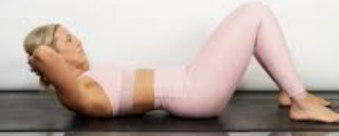

PRESS UPS

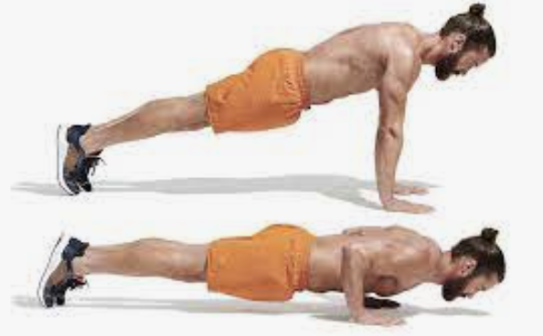

DORSAL RAISES

