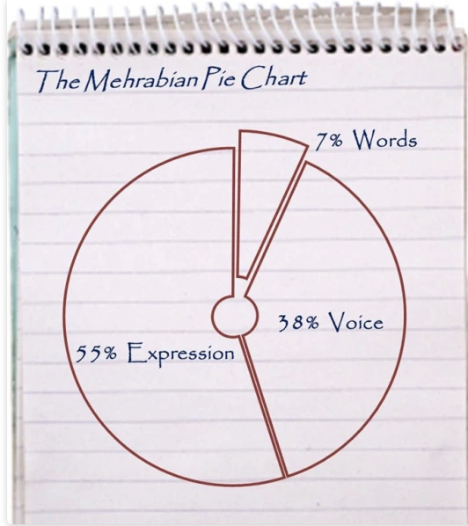

**PROXEMICS**



**PROXEMICS**

